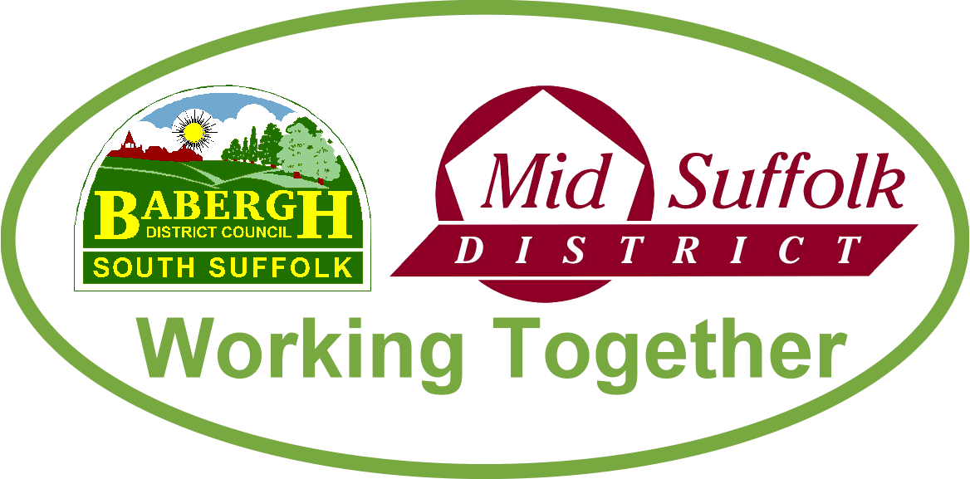

August 2022

Blueprint for the future of social housing approved
Babergh and Mid Suffolk District Councils have approved their blueprint for the future of social housing in our districts. It will ensure that our tenants have good quality and sustainable homes, in safe neighbourhoods. More information

Nominations now OPEN for the Innovations Awards
Our Innovation Awards showcase the talent, forward-thinking and innovation in business across Babergh and Mid Suffolk. This can be anything from using new ways to communicate with customers, delivering new services, launching new products, or integrating new, cutting-edge technology. There are nine free-to-enter categories covering a range of sectors. More information

Energy Rebate scheme to be extended
Residents in Babergh and Mid Suffolk who have been unable to access financial support through the Council Tax Energy Rebate Scheme may now be able to do so through a discretionary fund. More information

Wildflowers to spring up across Babergh and Mid Suffolk
Our councils are trialling wildflower verges across our districts, as part of efforts to tackle biodiversity and climate change. More information

£450,000 more funding for community causes now available
Community groups across Babergh and Mid Suffolk can now bid for a share of £450,000 to improve their neighbourhoods, thanks to the two new Community Development Grants. More information

Supporting our districts through recent extreme temperatures
Steps were put in place last month to support residents across Babergh and Mid during extreme weather conditions, with the first ever heat-related red weather warning issued for the county. More information

Councils take action to help restore empty homes into family homes
Babergh and Mid Suffolk Councils’ new Empty Homes Policy is set to reduce the number of long-term empty properties in the districts. There are currently over 1000 empty properties across the districts which, once restored, will help ease the growing demand for homes for residents. More information

Councils lead the way towards sustainable travel vision
Babergh and Mid Suffolk are taking the next step towards a sustainable travel solution, aiming to increase active travel and help tackle climate change. More information

Summer holiday activities to support families over the school break
An array of activities are being staged during the summer holidays to provide entertainment and support to families across Babergh and Mid Suffolk.

From adventure days to swimming, cooking classes to woodwork there is something to keep everyone occupied and active over the summer holidays thanks to Babergh and Mid Suffolk District Councils and partners. More information

Babergh District Council receives the keys to new social housing in Newton and Groton
Babergh District Council took delivery of more new social housing this month, this time in Newton and Groton. More information

