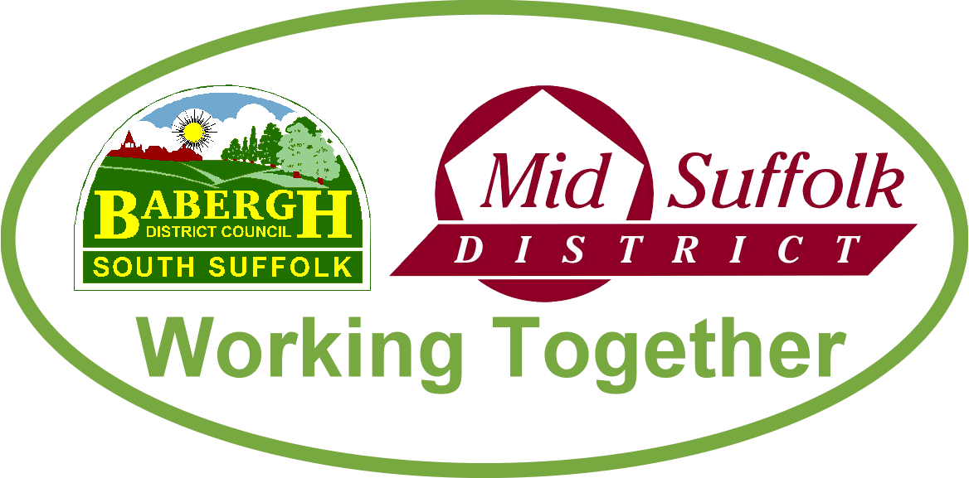
May 2022

Changes to Babergh Cabinet
Babergh District Council’s new Cabinet has now been announced:

- Cllr John Ward (Ind Con), leader and cabinet member for Economic Development
- Cllr Clive Arthey (Ind), deputy leader and cabinet member for Planning
- Cllr Dave Busby (Lib Dem), cabinet member for Finance, Assets and Investments
- Cllr Jane Gould (Green), cabinet member for Climate Change, Biodiversity and Sustainable Transport
- Cllr Liz Malvisi (Ind), cabinet member for Environment
- Cllr Alastair McCraw (Ind), cabinet member for Customers, Digital Transformation & Improvement
- Cllr Mary McLaren (Ind Con), cabinet member for Communities & Wellbeing
- Cllr Jan Osborne (Ind Con), cabinet member for Housing

Playing our part to support Ukrainian refugees
Both Babergh and Mid Suffolk District Councils have pledged their full backing for the Ukrainian people, with support for refugees arriving in our districts as part of the Homes for Ukraine scheme.

Both councils are represented on Suffolk’s Ukraine Task Group alongside representatives from the county’s other local authorities, three Clinical Commissioning Groups, Health Outreach, Suffolk police, Suffolk Refugee Support, Anglia Care Trust and Community Action Suffolk.

Our officers are responsible for carrying out property inspections of homes once sponsors in Babergh and Mid Suffolk are matched with a Ukraine family or individual by the Home Office. We are working hard to ensure homes are appropriate and safe as quickly as possible. More information is available on our website, including how to sign up for a weekly email update.

Payments of council tax energy rebates now underway
Payments of the Government’s £150 energy rebate are now well underway for eligible households across Babergh and Mid Suffolk. Find out more

Councils join forces with GPs to keep residents fit
Babergh and Mid Suffolk District Councils have expanded their GP referral schemes to include Hadleigh, providing tailored support for residents to improve their health and wellbeing. Find out more

Councils announce more accessible facilities
Four new Changing Places facilities will be created in key visitor locations in Babergh and Mid Suffolk following a successful bid for grant funding for almost £200,000. Find out more

Students find out more about film and TV careers
April saw the launch of the 2022 Careeriosity programme, with students in and around Sudbury invited to find out what career opportunities are available in the film and television sector at an exciting event by Babergh and Mid Suffolk District Councils and Screen Suffolk. Find out more

