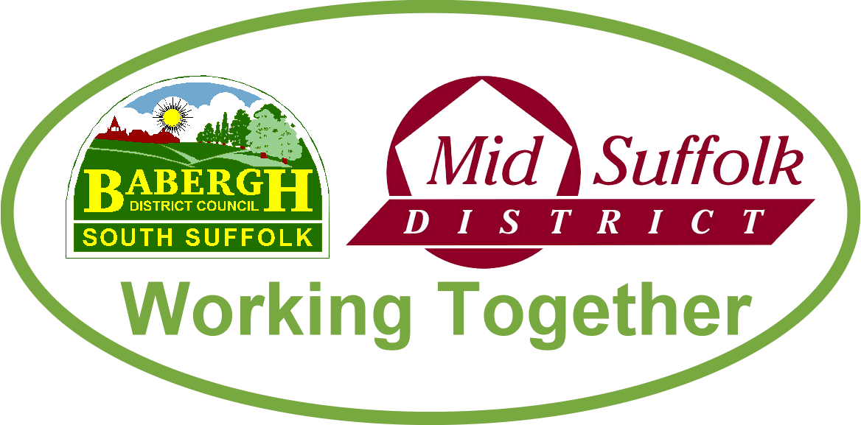

October 2022

The death of Her Majesty the Queen
Thank you to all our towns and parishes who helped residents to pay tribute to Her Majesty the Queen and send condolences to the Royal family. We recognise the effort behind the scenes in supporting our communities across our districts. Thanks in particular to our Town Council colleagues, who had the additional responsibility of staging the local proclamations of the reign of King Charles III.
Condolences to the Royal family from our councils
More information on the historic proclamations that took place across our districts

Councils set out parking strategy for the next 20 years
Supporting the needs of local trade and residents, while putting the brakes on climate change – Babergh and Mid Suffolk District Councils have set out their plans for improved parking provision for the next 20 years. More information

Bird flu outbreak
Information on the recent bird flu outbreak in Suffolk. More information

Latest CIL funding sees thousands ploughed back into communities
More than £420,000 in developer contributions is to be ploughed back into communities – helping to fund the renovation of Gainsborough’s House, and improved play equipment and bus facilities for villages. More information

A chance to stand for what you believe in
Residents across Babergh and Mid Suffolk are being encouraged to consider adding their name to the ballot and stand as a district councillor next May. More information

Households urged to get Food Savvy and plan ahead to save money and avoid waste
As the cost of living continues to bite a new campaign has been launched in Suffolk to help families reduce food waste and save money. More information

