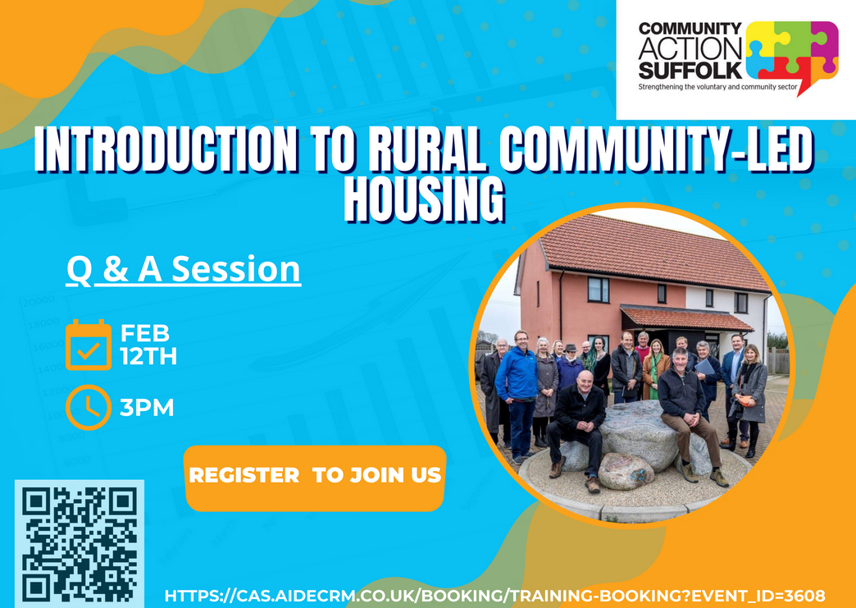

Introduction to Rural and Community Led Housing 2025

An Introduction to Rural and Community-Led Housing with Q&A session
Zoom session hosted by Community Action Suffolk

We are delighted to invite you to an ‘Introduction to Rural Community Led Housing’ Webinar , hosted by Community Action Suffolk. This informative session will explore how community-led housing can address local housing needs and benefit communities.
Event Details:
Date : 12th February 2025
Time: 3pm
The webinar will include a short presentation on rural and community led housing , its various forms and how it can prioritise affordable homes for local people. A live Q & A session will follow.
This event is ideal for parish councils, community organisations and residents interested in influencing local housing development. It is free to attend.
To join:
• Scan the QR code on the attached poster , or
• Register here : https://cas.aidecrm.co.uk/booking/training-booking?event_id=3608

For more information contact:
Phylis Ndono , Rural Housing Enabler, Community Action Suffolk
phylis.ndono@communityactionsuffolk.org.uk

